**First Semester 2023-24**

**Data Structures and Algorithms Design (Merged-SEZG519/SSZG519)**

**Exercises (Algorithm Design Techniques)**

1. Draw stack and queue statuses for each iteration of DFS and BFS for the following graph.

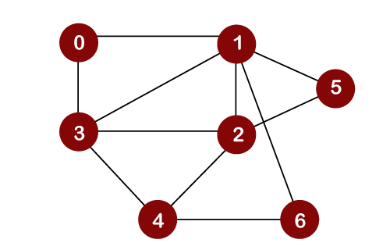

1. Write the iterations of making change problem using greedy algorithm and dynamic programming for the following inputs. Write your observations about greedy and dynamic programming approaches for this input.

Input: Coins = {1,2,5,10}, Amount: 19

1. Draw iteration tables for Prim’s and Kruskal’s algorithms on the following graph.

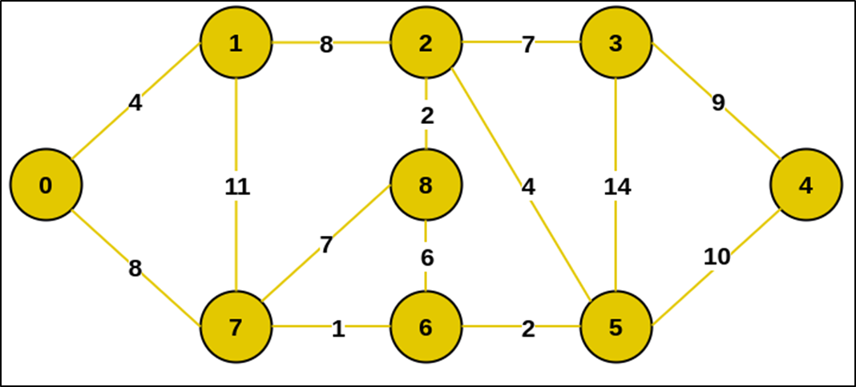

1. Draw the iteration tables of Dijkstra’s, Bellman-Ford, and Floyd Warshall's algorithms for the following graph.

